Assignment No. 1
Process Model Selection
University Timetable Optimization and Management System
Course | Software Engineering
Document Type | Process Model Assignment
Project | University Timetable Optimization and Management System
Prepared For | Submission / project documentation

Prepared using the project brief, the uploaded example structure, and the compiled prerequisite research.

1. Introduction
The proposed project is a web-based University Timetable Optimization and Management System. Its goal is to automate timetable preparation for courses, teachers, sections, rooms, and student groups while respecting institutional rules and optional policy preferences.
This assignment selects a suitable software process model for the project. The decision is based on the nature of the problem, expected requirement changes, visual prototyping needs, technical risk, and the need to deliver a working system in semester-sized increments.

2. Project Overview
The timetable project is not a simple data-entry website. It combines administrative data management with rule definition, timetable generation, conflict review, controlled manual changes, and publication of the final schedule.
• manage departments, semesters, courses, sections, teachers, rooms, buildings, and time slots
• record teacher availability, room availability, holidays, and blocked periods
• support policy choices such as continuous classes, morning preference, early day ending, room proximity, and minimal-disruption updates
• generate and review timetables before publication
• allow manual adjustments and re-optimization when a teacher or room changes

3. Core Requirements Considered
• A weekly timetable must be generated for multiple teachers, classes, student groups, and rooms.
• The system must respect hard constraints such as no teacher clash, no room clash, and no section conflict.
• The system should optimize soft preferences such as compact schedules, room stability, and policy-driven customizations.
• The user interface should allow non-technical academic staff to define rules without writing code.
• The final system should support later timetable repair instead of always rebuilding everything from scratch.

4. Selection Criteria
The following criteria were used to decide the most suitable process model for the project.
Criterion | Why it matters
Requirement volatility | Timetable rules and preferences are likely to change after prototype feedback.
Technical risk | Generation, validation, and re-optimization introduce more uncertainty than an ordinary CRUD system.
Need for prototyping | The system is highly visual; stakeholders understand it better after seeing screens and draft timetables.
Time and scope | A semester project benefits from phased delivery and visible partial progress.
Documentation | The subject requires formal written work, so the process must still support clear documentation.
Testing strategy | Each module should be testable as it is completed.

5. Comparison of Candidate Process Models
Before selecting a model, several common software process models were considered.
Model | Strengths | Weaknesses | Fit
Waterfall | Strong documentation; easy to explain | Rigid when rules change after seeing first timetable outputs | Partially suitable
Incremental | Builds the system in modules and supports feedback after each increment | Needs planning to keep increments coherent | Most suitable
Spiral | Good for risk-driven work | Heavier than needed for a semester project | Possible alternative
Agile / XP | Fast adaptation and frequent feedback | Can become weakly documented if not controlled | Useful as a supporting mindset

6. Selected Process Model
The selected model is the Incremental Process Model with Prototyping support. This model allows the team to build the project in well-defined stages while still validating the user interface, workflows, and rule configurations through early visual prototypes.

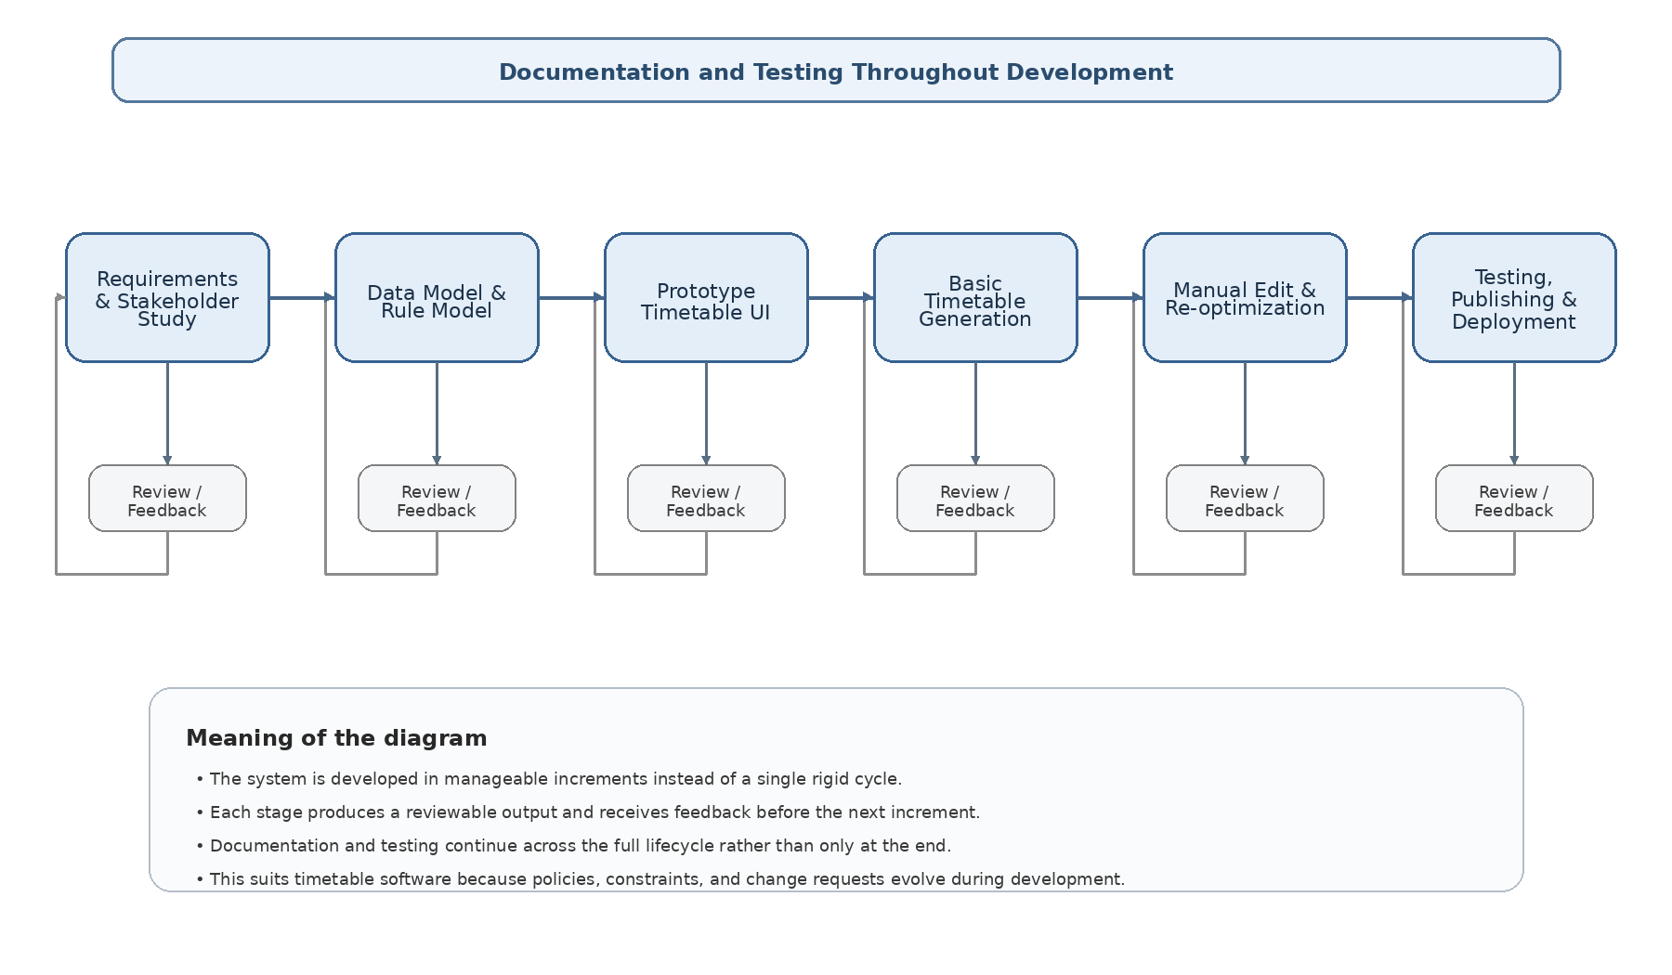
Figure 1. Incremental Process Model for the timetable project.

6.1 Diagram Description – Incremental Process Model
The process model diagram shows that development starts with requirements and stakeholder study, proceeds through data and rule modelling, then moves into a prototype of the timetable interface before the team attempts full generation logic. After that, the project grows through timetable generation, manual edit and re-optimization, and finally testing, publishing, and deployment. Under each major phase a review/feedback activity is shown to indicate that every increment is validated before the next one begins. The long header at the top emphasizes that documentation and testing continue throughout the entire lifecycle rather than only at the end.

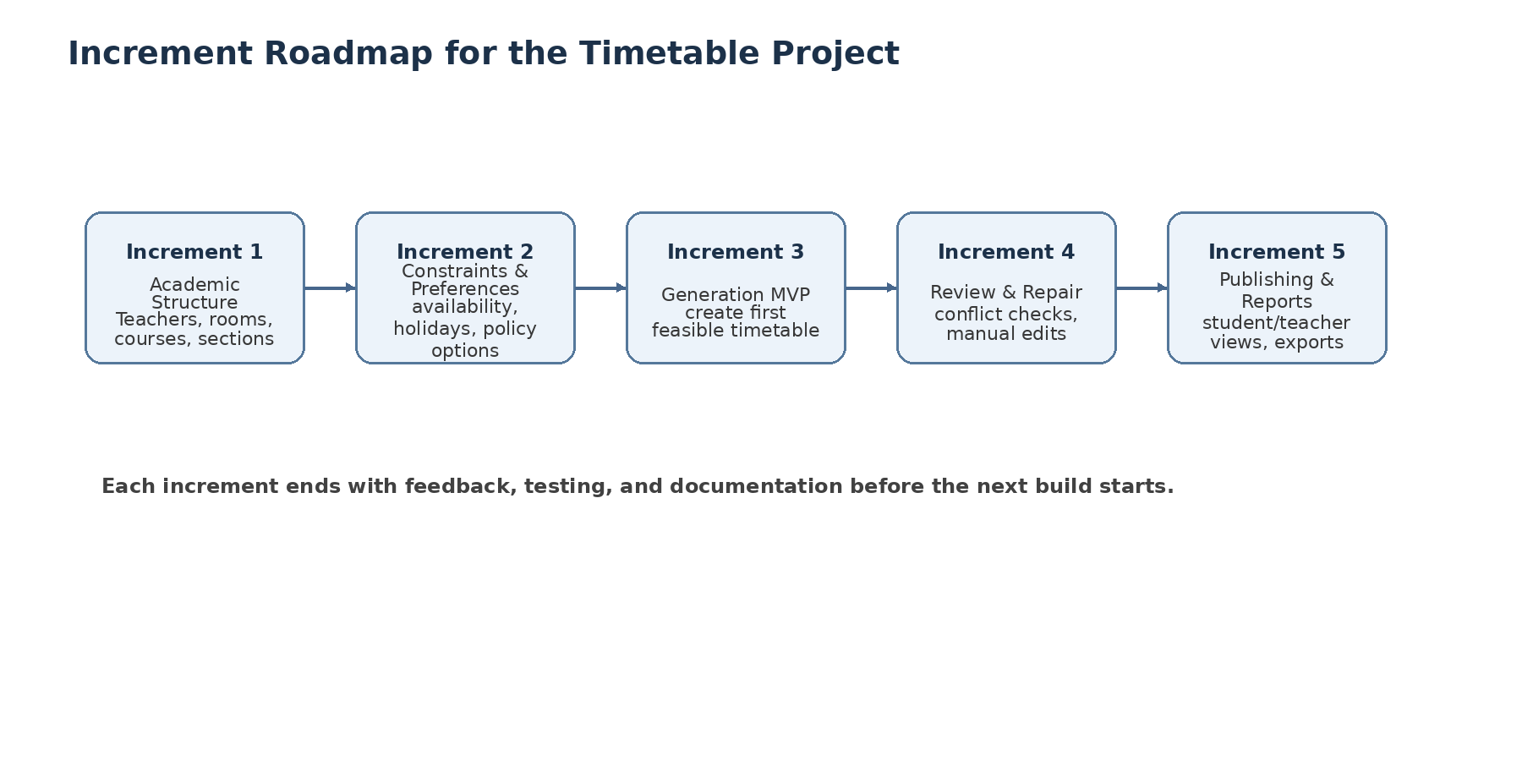
Figure 2. Suggested semester-sized roadmap for incremental delivery.

6.2 Diagram Description – Increment Roadmap
The roadmap diagram breaks the system into practical delivery stages. Increment 1 establishes the academic structure and master data. Increment 2 adds constraints and policy preferences. Increment 3 delivers a first timetable generation MVP. Increment 4 focuses on review, repair, and manual edits. Increment 5 completes publishing, views, and reports. This sequencing reduces risk and keeps the project demonstrable at every stage.

7. Detailed Justification

7.1 Requirements are expected to evolve
University timetable systems often reveal missing rules only after users inspect a first draft schedule. Examples include teacher-specific exceptions, room-nearness requirements, holiday blocks, policy toggles, and minimal-impact adjustments. A rigid one-pass process would make such changes expensive.

7.2 The project is both visual and rule-heavy
Stakeholders need to see forms, timetable grids, conflict summaries, and configuration screens. A prototype helps validate the interface and the meaning of the rules long before the full engine is complete.

7.3 The system naturally decomposes into modules
Master data, constraint definition, generation, validation, repair, and publishing are distinct pieces. Incremental development maps neatly onto this modular structure.

7.4 Technical risk can be isolated early
Instead of waiting for a final build, the team can test conflict checking, schedule generation, and change handling as separate milestones.

7.5 Continuous testing becomes practical
Each increment can be tested with sample datasets. This includes input validation tests, conflict checks, view rendering checks, and change-impact checks.

7.6 Documentation remains strong
Incremental delivery does not reduce documentation quality. Requirements, diagrams, tables, UI descriptions, and test notes can be updated after each increment.

7.7 The model supports later algorithm work
The current phase focuses on prerequisites and system structure. The optimization engine can later be improved without redesigning the whole application.

8. Why Waterfall Was Not Selected
Waterfall is easier to justify when requirements are already stable and unlikely to change. In this project, however, institutional goals and timetable preferences can shift after the first prototype or generated timetable is reviewed. Because of that, Waterfall would create unnecessary rigidity.

9. Alternative Models
Alternative | Possible use
Spiral Model | Strong option if the project is presented as highly risk-driven due to timetable generation complexity.
Prototype Model | Useful when the instructor wants heavy emphasis on early visual feedback and user approval.
Agile / XP | Good supporting mindset for short iterations, but should be combined with stronger documentation discipline for coursework.

10. Proposed Increment Plan
Increment | Focus | Deliverables
Increment 1 | Master data | Departments, courses, sections, teachers, rooms, and time slots
Increment 2 | Rules and policies | Availability, holidays, room features, custom preferences, policy toggles
Increment 3 | Generation MVP | Create the first feasible timetable and show a basic score/report
Increment 4 | Repair and edit | Manual changes, re-optimization, minimal-disruption updates
Increment 5 | Publishing | Teacher views, student views, room views, reports, and export

11. Conclusion
The Incremental Process Model with Prototyping support is the most suitable process model for the University Timetable Optimization and Management System. It matches the project’s modular structure, supports evolving requirements, reduces technical risk, and still fits the documentation expectations of a software engineering assignment.

12. Reference Notes
This assignment was written using the project brief, the uploaded teacher/example format, and the previously compiled prerequisite research on university course timetabling, process-model fit, and current timetabling system practice.

